Kalvin Patarawong

Student ID: 009931191

Date: 2/11/2025

C951 Chat Bot

A: EXPLANATION OF CHATBOT FUNCTIONALITIES
In this scenario, the chatbot is a virtual career advisor for students in a university's computer science program. Its goal is to help students identify potential computing jobs based on their personal preferences and strengths. Since the number of students enrolling in the Computer Science program has been increasing, the chatbot was developed to reduce the workload of career advisors, enabling the bot to interact with students individually and assist them in finding suitable career paths.
Functionality Overview:
- Initial Interaction: The bot starts by greeting the student and asking them to type "Start" to begin their career exploration.
- Personalization: After receiving the student's name, the bot customizes its interaction based on their interest in math. Students who like math will be shown careers that require strong mathematical skills, while those who don't will be presented with non-math-intensive careers.
- Career Path Selection: The bot provides students with a choice of five different career paths depending on their mathematical preferences:
  - For math enthusiasts: Software Developer/Engineer and Data Scientist.
  - For non-math enthusiasts: Cybersecurity Analyst, Systems Administrator, and UX/UI Designer.
- Informational Resources: For each career path, the bot shares relevant details and provides a link to external resources for further exploration.

B: COMPUTING JOB TYPES
Each career represents a different area within Computer Science, so the chatbot gives you options based on your interests. Here are the five computing job types that the chatbot recommends based on the user’s input:
- Software Developer/Engineer
- Data Scientist
- Cybersecurity Analyst
- Systems Administrator
- UX/UI Designer

C: CHATBOT CODE FILES

This was provided as a zip file with this paper.

D: CHATBOT TRAINING CASES
This chatbot's training cases were selected based on different student profiles and their interests in math and computing careers. These cases help refine how the chatbot can handle various situations and guide users to career paths that suit their preferences.

Training Case Examples:

Case 1: A student who has strong programming skills and enjoys math, like James, would be shown careers that require high mathematical skills, such as Software Developer/Engineer and Data Scientist. This case demonstrates how the bot helps math lovers explore programming and data-related careers.

Case 2: John, a student who dislikes math, would be presented with career paths like UX/UI Designer, Systems Administrator, and Cybersecurity Analyst, which does not focus on math.

How AIML and Functionality Were Improved:
The chatbot was fine-tuned to recognize and appropriately respond to different user inputs, ensuring a smooth interaction. For instance:
- If a student like James types “Yes” in response to a math-related question, the chatbot provides specific careers that require math, such as Software Developer.
- If a student like John types “No,” the chatbot presents careers that do not emphasize math, like UX/UI Designer, and explains the nature of these jobs.
The AIML file was adjusted to handle these types of cases by:
- Pattern matching recognizes different inputs like “Yes” or “No.”
- Customizing responses based on the user’s choice ensures the bot recommends careers based on their math preferences and interests.

Training case code:
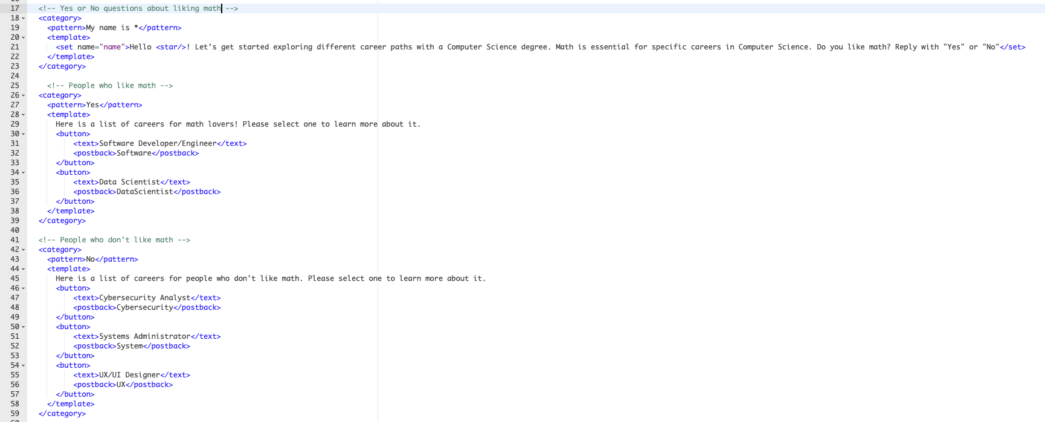

E: INSTALLATION MANUAL
Instruction for Accessing Pandorabots chatbot with Link:
- Log into Pandorabots:
  - Through a browser, go to https://home.pandorabots.com.
  - Sign in using your Pandorabots account or create an account.
- Access Chatbot:
  - Click on the web link below to access the deployed live chat: https://home.pandorabots.com/dash/bot-directory
  - In the search bar, type the chatbot's name “C951_WGUBot”.
  - Click on the bot’s name to go to its dashboard.
- Test the Bot:
  - In the message window, type “hi” or “Start” to start interacting with the bot.
  - The bot will greet you and help you explore different career paths based on your preferences.
- Link to Deployed Bot: https://home.pandorabots.com/dash/bot-directory
Instructions for Deploying an AIML File on Pandorabots
- Log in to Pandorabots:
  - Open a browser and go to https://home.pandorabots.com.
  - Sign in using your existing Pandorabots account or create a new account.
- Upload AIML File:
  - After logging in, you’ll be directed to the Dashboard.
  - In the top-left corner of the Dashboard, find the "MY BOTS" section and click the plus icon to the right to create a new bot.
  - A "Create Bot" screen will appear. Fill in the following details:
    - Bot Name: “C951_WGUBot”
    - Language: English
    - Content: Blank Bot
  - A new bot named "C951_WGUBot" will be created under the "MY BOTS" section.
  - Click on "C951_WGUBot," then select Edit and click Code Editor to access the bot's code.
- Upload the AIML File:
  - Download the file wgubot.zip and unzip it to access the AIML file.
  - In the Code Editor, click on File in the top-left corner and select Upload.
  - In the upload screen, click Select Files, navigate to the unzipped “wgubot” folder, and select the “wgubot.aiml” file to upload.
- Test the AIML File:
  - After uploading the AIML file, click on AIML in the Code Editor to ensure the “wgubot” file is correctly loaded. You can review the chatbot’s code here.
  - To test the bot, look for the Test Bot icon in the bottom-right corner of the screen. If it’s missing, click “C951_WGUBot” in the navigation bar on the left, then return to the Code Editor. The Test Bot should appear.
  - Enter a sample message like “hi” or “start” in the message window. If the bot responds appropriately, the AIML file has been successfully uploaded.
- Deploy the Chatbot:
  - To deploy the bot, click “C951_WGUBot” in the navigation bar, then click Deploy.
  - You can deploy the chatbot to an Internal Bot Directory in the Sandbox by clicking Set Up.
  - Fill out the Add to Bot Directory screen with the following details:
    - Type: Assistance
    - Name: Choose a name for your chatbot
    - Description: Provide a brief description of your chatbot’s function.
- Access the Live Chatbot:
  - In the navigation bar, go to the Directory section.
  - Search for the name of the bot you deployed and click on it.
  - Type “hi” or “start” in the message window to begin interacting with your bot.
  - The bot will greet you and guide you through different career paths based on your preferences.

F: CHATBOT ENVIRONMENT
Strengths:
- User-Friendly Interface: The Pandorabots platform is easy to use and allows the quick creation of AIML-based chatbots. This helped develop the chatbot efficiently without being bogged down by complex technical details.
- Good Documentation and Support: Pandorabots provides excellent resources to help developers troubleshoot and improve the chatbot. This was a significant strength, as it made it easier to resolve issues during the development process.
Weaknesses:
- Limited Natural Language Processing: Pandorabots’ AIML system relies on pattern matching, which can be limiting when users don’t follow exact patterns. For example, if a student types “I like math” instead of “Yes,” the bot might not understand it correctly.
- Platform Restrictions: The free version of Pandorabots has limitations, especially when handling high traffic. If many students interact with the bot at once, it could become slow or unresponsive, which is a drawback.

G: MONITORING AND MAINTAINING
By making updates, the chatbot will continue to offer valuable career advice and improve its ability to guide students toward the right career paths. Maintenance and monitoring will be necessary to keep it running smoothly and enhance the user experience.
- Collect Feedback: After each interaction, students can provide feedback, helping identify issues or areas where the chatbot can be improved.
- Update Career Information: As industries evolve, career paths may change. Regular updates to the job descriptions and links will ensure the bot remains up to date.
- Analyze Chatbot Performance: Tracking which career paths are most popular and how users interact with the bot can provide insights on refining the chatbot for future users.

